**WEB PROGRAMING PRACTICUM REPORT**

**MODULE 3**

**PHP**



**CREATED BY :**

**KURNIAWAN BAGASKARA**

**L200214253**

**INFORMATICS STUDY PROGRAM**

**FACULTY OF COMMUNICATION AND INFORMATION SCIENCE**

**MUHAMMADIYAH SURAKARTA UNIVERSITY**

**Test 1.**

<!DOCTYPE *html*>

<html>

<head>

    <title>Variable</title>

</head>

<body>

    <h1>Buku Tamu</h1>

    <form *method*="POST" *action*="variable.php">

        <p>Nama : <input *type*="text" *name*="nama" *size*="20"></p>

        <p>Email : <input *type*="text" *name*="email" *size*="30"></p>

        <p>Komentar : <textarea *name*="komentar" *cols*="30" *rows*="3"></textarea></p>

        <p><input *type*="submit" *name*="submit" *value*="kirim"></p>

    </form>

<?php

error_reporting(E_ALL ^ E_NOTICE);

$nama = $_POST["nama"];

$email = $_POST["email"];

$komentar = $_POST["komentar"];

$submit = $_POST["submit"];

if ($submit) {

    echo "<br>Nama : $nama";

    echo "<br>Email : $email";

    echo "<br>komentar : $komentar";

}

?>

</body>

</html>

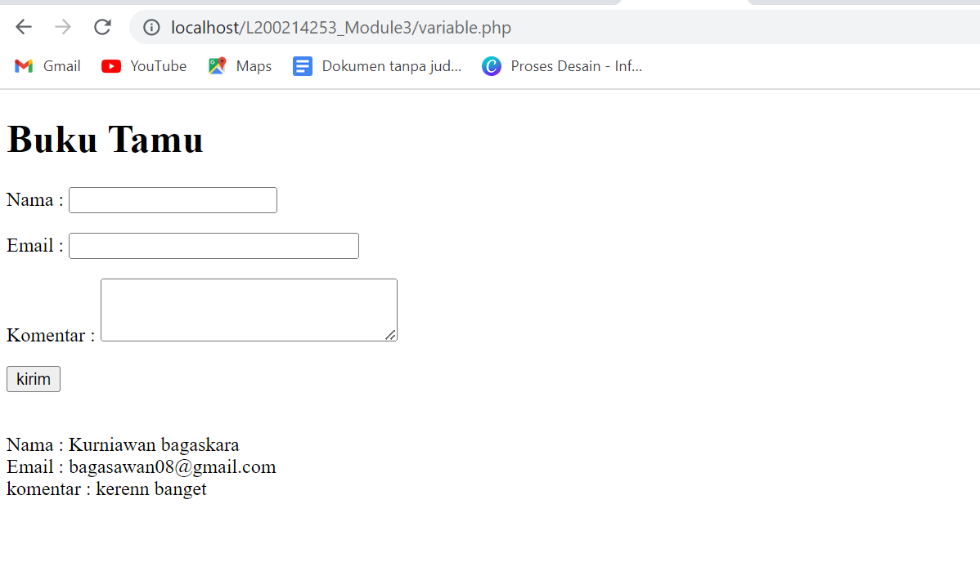

**Test 2.**

<!DOCTYPE *html*>

<html>

<head>

    <title>Variable</title>

</head>

<body>

    <h1>Nilai</h1>

    <form *method*="POST" *action*="kendali.php">

        <p>Masukkan nilai angka (0-100) : <input *type*="text" *name*="nilai" *size*="3"></p>

        <p><input *type*="submit" *name*="submit" *value*="Proses"></p>

    </form>

<?php

error_reporting(E_ALL ^ E_NOTICE);

$nilai = $_POST["nilai"];

$submit = $_POST["submit"];

if ($submit) {

    if ($nilai == "") {

        $huruf = "Nilai kosong/belum diisi";

    }

    elseif ($nilai <= 20) {

        $huruf = "E";

    }

    elseif ($nilai <= 40) {

        $huruf = "D";

    }

    elseif ($nilai <= 60) {

        $huruf = "C";

    }

    elseif ($nilai <= 80) {

        $huruf = "B";

    }

    elseif ($nilai <= 100) {

        $huruf = "A";

    }

    else{

        $huruf = "Nilai yang dimasukkan salah!";

    }

    echo "Nilai angka adalah $nilai <br>";

    echo "Maka nilai huruf adalah $huruf";

}

?>

</body>

</html>

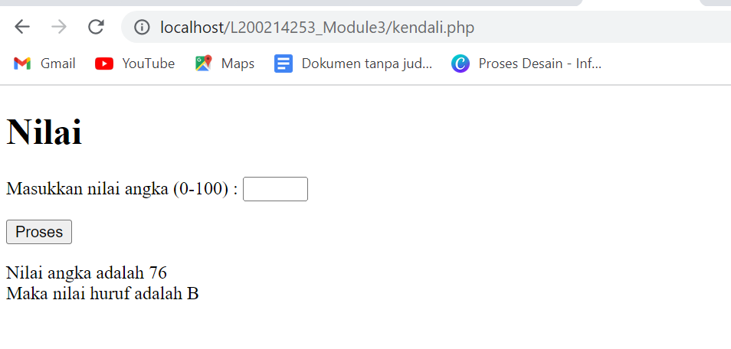

**Test 3.**

<!DOCTYPE *html*>

<html>

<head>

    <title>Upload Files</title>

</head>

<body>

<?php

error_reporting(E_ALL ^ E_NOTICE);

$direktori = "images/";

$nama_foto = $_FILES["foto"]["name"];

$size_foto = $_FILES["foto"]["size"];

$tipe_foto = $_FILES["foto"]["type"];

$upload = $direktori.$nama_foto;

$submit = $_POST["submit"];

if ($submit) {

    move_uploaded_file($_FILES["foto"]["tmp_name"], $upload);

    echo "<h3>Fie berhasil diupload</h3>

            <br><br>

            <img border ='0' src = '$upload'><br><br>

            <b>Informasi file : <br><br>

            Nama file : $nama_foto <br>

            Ukuran file : $size_foto<br>

            Tipe file : $tipe_foto<br>";

}

else{

    ?>

    <form *method*="POST" *enctype*="multipart/form-data" *action*="upload.php">

        Upload file : <input *type*="file" *name*="foto" *size*="20"><br>

        <input *type*="submit" *name*="submit" *value*="UPLOAD">

    </form>

    <?php

}

?>

</body>

</html>

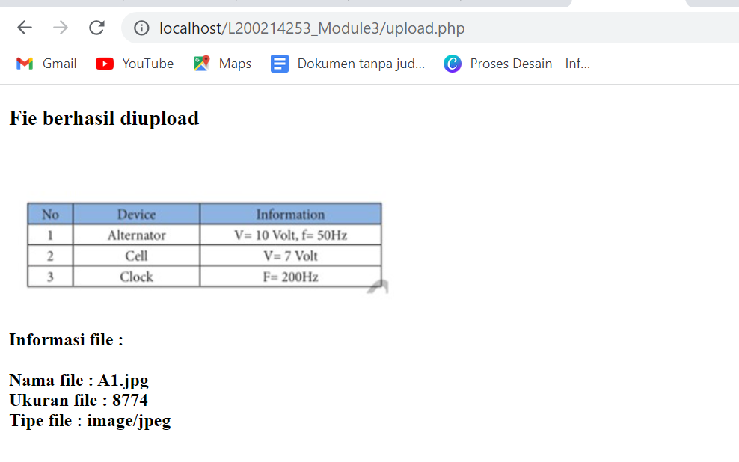

**Test 4.**

<!DOCTYPE *html*>

<html>

<head>

    <title>Fungsi Tanggal dan Waktu</title>

</head>

<body>

    <?php

    date_default_timezone_set("Asia/Jakarta");

    $jam = date("H:i:s A");

    $waktu = date("d-m-Y");

    $hari = date("l");

    $tanggal = date("d");

    $bulan = date("F");

    $tahun = date("Y");

    echo "Sekarang jam $jam<br>";

    echo "Sekarang tanggal $tanggal <br>";

    echo "Lebih detailnya hari $hari tanggal $tanggal bulan $bulan tahun $tahun";

    ?>

</body>

</html>

